**IOT BASED HOME ENERGY MONITOR**

***Project Report submitted***

***In Partial Fulfilment of the Requirements for the award of the degree***

***of***

***Bachelor of Technology***

***In***

***Electrical and Electronics Engineering***

***by***

**CH.DEVI. SURYA.TEJA (168W1A0266)**

**M.ADINARAYANA (168W1A0287)**

**M.PRASANNA KUMAR (168W1A0288)**

**Under the guidance of**

**Dr.J.Ramesh,(Ph.D)**

**Associate Professor**



**DEPARTMENT OF**

**ELECTRICAL AND ELECTRONICS ENGINEERING**

**VELAGAPUDI RAMAKRISHNA**

**SIDDHARTHA ENGINEERING COLLEGE (AUTONOMOUS)**

***(Affiliated to JNTUK, Approved by UGC, Accredited By NBA)***

**JULY 2020**

**CERTIFICATE**



# *This is to certify that, the project report entitled “****IOT BASED HOME ENERGY MONITOR****” is the bonafide record of work carried out by* ***CH.DEVI.SURYA TEJA (168W1A0266.), M.ADINARAYANA (168W1A0287.), M.PRASANNA KUMAR (168W1A0288****), under my guidance and submitted on partial fulfillment of the requirements for the award of the degree of Bachelor of Technology in Electrical and Electronics Engineering to Jawaharlal Nehru Technological University Kakinada during the academic year 2019- 2020.*

**Dr.J.Ramesh Dr.P.V.R.L.Narasimham.**

Associate Professor Professor & Head

Department of E.E.E. Department of E.E.E.

**ACKNOWLEDGEMENT**

First of all ,we sincerely salute our esteemed institution **VELAGAPUDI RAMAKRISHNA SIDDHARTHA ENGINEERING COLLEGE** for giving us this golden opportunity of fulfilling our dream of becoming engineers.

We thank our honorable principal **Sri A.V.RATNA PRASAD** for his kind co-operation and for providing the department facilities like computer, Electronics lab and internet.

We are happy to express our heart gratitude and thanks for our guide **Dr.J.RAMESH**, Associate Professor, E.E.E department for his valuable suggestions and term paper in time successfully.

We are grateful to the department, **Dr.P.V.R.L.NARASIMHAM** garu for always encouraging us and being ever ready to help us.

We are also very much thankful to our EEE department staff and lab technicians for their valuable suggestions and co-operation.

**TABLE OF CONTENTS: PAGE NO:**

1. **ABSTRACT 1**
2. **INTRODUCTION 2**
3. **COMPONENTS 3-13**

3.1 HARDWARE

3.1.1 ARDUINO 3

3.1.2 VOLTAGE TRANSFORMER 7

3.1.3 CURRENT TRANSFORMER 8

3.1.4 OPERATIONAL AMPLIFIER 9

3.1.5 EX-OR GATE 10

3.1.6 LCD DISPLAY 12

3.2 SOFTWARE

3.2.1 ARDUINO IDE 13

1. **ENERGY MEASUREMENT 14-23**

4.1 MEASUREMENT OF VOLTAGE 14

4.2 MEASUREMENT OF CURRENT 15

4.3 MEASUREMENT OF POWER FACTOR 16

4.4 CALCULATION OF ENERGY 18

4.5 MEASURED ENERGY OUTPUT ON LCD 19

DISPLAY

4.6 ARDUINO CODE 20

**5. WORKING 23**

**6. APPLICATIONS 24**

**7. CONCLUSION 25**

**8. REFERENCES 26**

**CHAPTER-1**

**ABSTRACT**

An implementation of IOT based home energy monitoring system is proposed to minimize the energy consumption cost in terms of effective utilization of household electric appliances. In real time application increasing the cost of power consumption plays a vital role in chaotic financial management. Moreover, due to modern life style and economic status of the family urge to use of more powered appliances without consciously considering the effects of over utility. Hence, monitoring and control of power utilities are utmost priority. This is intended to develop a home energy monitoring device, which is based on microcontroller that monitors the power consumption of each device at home and gives a detailed report. This can be viewed over IOT connected devices as well as it stores this data. This provides the consumer an idea how the power being consumed and help them to reduce it. However, everyone wishes to save the energy and money to reach their targets. Hence, minimizing the monthly electricity bill is a good place to start. On the other hand, not only for household appliances it can be used in small scale industries. To evaluate the proposed technique a prototype hardware model to be developed with IOT based Arduino. This system will gives satisfactory performance in the real time applications.

**CHAPTER-2**

**INTRODUCTION**

The electricity sector in India is dominated by fossil fuels, particularly coal, which produced about two-thirds of all electricity in the year 2016. However, only the investment of renewable energy is increased by the Government. The draft National Electricity Plan of 2016 prepared by the Government of India states that the country does not need additional non-renewable power plants in the utility sector until 2027, with the commissioning of 50,025 MW coal-based power plants under construction and achieving 275,000 MW total installed renewable power capacity.

India became the third-largest producer of electricity in the world with 4.8% of the global share. Out of the total power generated the renewable energy constituted about 28.43% and the non-renewable energy constituted about 71.57%. Electricity is a vital requirement for leading a comfortable life. It is to be properly used and managed. At present, the human operator from the Electricity Board visits the resident to take the readings from the energy meter and produces the bill for the particular month manually.

The idea being proposed is to monitor energy consumption daily and monthly .It is done by using an Arduino UNO .It contains an LCD which helps us to see those values of power and energy**.**

**CHAPTER 3:**

**COMPONENTS**

**3.1 Hardware:**

Hardware is most important part of any system.Output devices like printers,displays and scanners can be connected to obtain the data.

**3.1.1 Arduino:**

Arduino used: ARDUINO UNO REV3

**Arduino Uno** is a microcontroller board based on the ATmega32. It has 14 digital input/output pins (of which 6 can be used as PWM outputs), 6 analog inputs, a 16 MHz quartz crystal, a USB connection, a power jack, an ICSP header and a reset button. It contains everything needed to support the microcontroller. The Arduino Uno can be programmed with the [Arduino Software](https://www.arduino.cc/en/Main/Software) IDE. The ATmega328 on the Arduino Uno comes pre -programmed with a [bootloader](https://www.arduino.cc/en/Hacking/Bootloader?from=Tutorial.Bootloader) that allows you to upload new code to it without the use of an external hardware programmer. It communicates using the original STK500 protocol . You can then use [Atmel's FLIP software](http://www.atmel.com/products/microcontrollers/default.aspx) (Windows) or the [DFUprogrammer](http://dfu-programmer.github.io/) (Mac OS X and Linux) to load a new firmware. Or you can use the ISP header with an external programmer.

**Power:**

The Arduino Uno board can be powered via the USB connection or with an external power supply. The power source is selected automatically .External (non-USB) power can come either from an AC-to-DC adapter (wall-wart) or battery. The adapter can be connected by plugging a 2.1mm center-positive plug into the board's power jack. Leads from a battery can be inserted in the GND and Vin pin headers of the POWER connector.

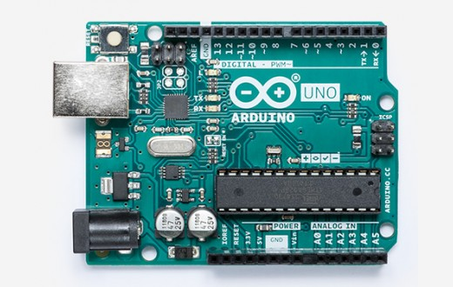

Arduino UNO REV3 Fig:3.1.1 a

The board can operate on an external supply from 6 to 20 volts. If supplied with less than 7V, however, the 5V pin may supply less than five volts and the board may become unstable. If using more than 12V, the voltage regulator may overheat and damage the board. The recommended range is 7 to 12 volts.

The power pins are as follows:

* Vin. The input voltage to the Arduino/Genuino board when it's using an external power source (as opposed to 5 volts from the USB connection or other regulated power source). You can supply voltage through this pin, or, if supplying voltage via the power jack, access it through this pin.
* 5V.This pin outputs a regulated 5V from the regulator on the board. The board can be supplied with power either from the DC power jack (7 - 12V), the USB connector (5V), or the VIN pin of the board (7-12V). Supplying voltage via the 5V or 3.3V pins bypasses the regulator, and can damage your board.
* 3V3. A 3.3 volt supply generated by the on-board regulator. Maximum current draw is 50 mA.
* GND. Ground pins. IOREF. This pin on the Arduino/Genuino board provides the voltage reference with which the microcontroller operates. A properly configured shield can read the IOREF pin voltage and select the appropriate power source or enable voltage translators on the outputs to work with the 5V or 3.3V.

**Memory:**

The ATmega328 has 32 KB (with 0.5 KB occupied by the bootloader). It also has 2 KB of SRAM and 1 KB of EEPROM.

PIN MAPPING OF ATMEGA 168

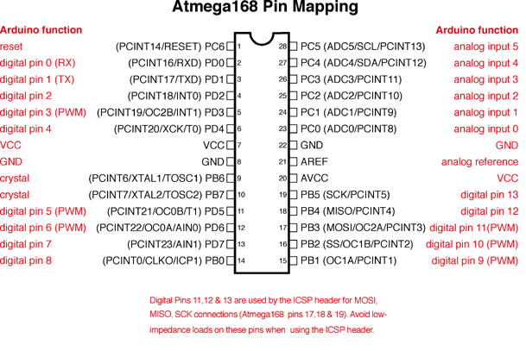

Fig:3.1.1 b

Each of the 14 digital pins on the Uno can be used as an input or output using,pinMode(),digitalWrite(),and digitalRead() functions. They operate at 5 volts. Each pin can provide or receive 20 mA as recommended operating condition and has an internal pull-up resistor (disconnected by default) of 20-50k ohm. A maximum of 40mA is the value that must not be exceeded on any I/O pin to avoid permanent damage to the microcontroller.

In addition, some pins have specialized functions:

* Serial: 0 (RX) and 1 (TX). Used to receive (RX) and transmit (TX) TTL serial data. These pins are connected to the corresponding pins of the ATmega8U2 USB-to-TTL Serial chip.
* External Interrupts: 2 and 3. These pins can be configured to trigger an interrupt on a low value, a rising or falling edge, or a change in value. See the attach Interrupt() function for details.
* PWM: 3, 5, 6, 9, 10, and 11. Provide 8-bit PWM output with the analogWrite() function.
* SPI: 10 (SS), 11 (MOSI), 12 (MISO), 13 (SCK). These pins support SPI communication using the SPI library.
* LED: 13. There is a built-in LED driven by digital pin 13. When the pin is HIGH value, the LED is on, when the pin is LOW, it's off.
* TWI: A4 or SDA pin and A5 or SCL pin. Support TWI communication using the Wire library.

The Uno has 6 analog inputs, labeled A0 through A5, each of which provide 10 bits of resolution (i.e. 1024 different values). By default they measure from ground to 5 volts, though is it possible to change the upper end of their range using the AREF pin and the analogReference() function. There are a couple of other pins on the board.

* AREF. Reference voltage for the analog inputs. Used with analogReference().
* Reset. Bring this line LOW to reset the microcontroller. Typically used to add a reset button to shields which block the one on the board.

**3.1.2 Voltage Transformer:**

Voltage Transformer is used to step down AC voltage which is further used for measurement by Arduino.The voltage transformer we are using here is (230V/9-0-9V)AC center-tapped step down transformer with a current rating of 500mA.

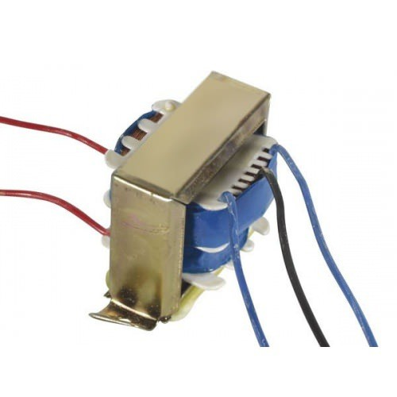

Fig:3.1.2Voltage Transformer(230V/9-0-9V)AC

**3.1.3 Current Transformer:**

The current transformer is used to step down AC current to smaller suitable values to make it suitable for measurement purposes .The current transformer we are using here is (100A/50mA)AC step down transformer clamp type. Model no: SCT013.

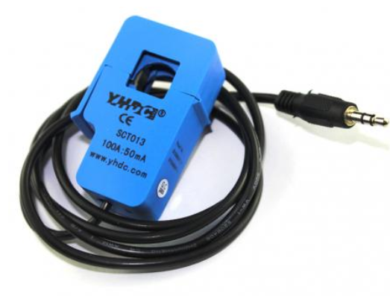

Fig:3.1.3Current Transformer SCT013 (100A/50mA)

**3.1.4 Operational Amplifier IC LM-358:**

The LM-358 series consists of two independent, high internally frequency compensated operational amplifiers internally Frequency Compensated for Unity Gain from a single power supply over a wide range of voltages. Operation from split power supplies is also possible and the low power supply current drain independent of the magnitude of the power supply .Application areas include transducer amplifiers, dc gain blocks and all the conventional op-amp circuits which now can be more easily implemented in.

**LM-358** is a dual op-amp IC integrated with two op-amps powered by a common power supply.The power supply to power LM-358 can be ranged from 3V-32V for single power supply and + or -1.5V to + or -16V for dual power supply.

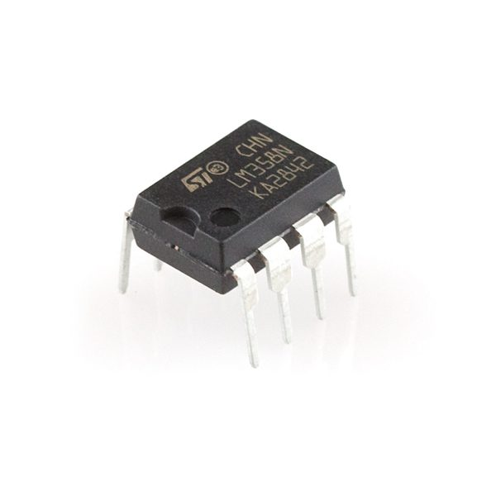

Fig:3.1.4 a LM-358 op-amp

This op-amp converts output signals sinusoidal signals coming from Voltage and current transformers into square waveforms of same phase of their corresponding sinusoidal waves but magnitude of around 4V.

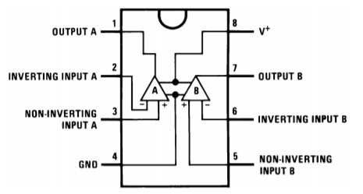

Fig:3.1.4 b Pin diagram of IC LM-358

**3.1.5 Exclusive OR Gate IC SN-74HC86N:**

SN-74HC86N is Quad 2-Input EXOR Gate 14 Pin IC. It is an advanced high speed CMOS 2−input Exclusive−OR gate fabricated with silicon gate CMOS technology. It achieves high speed operation similar to equivalent Bipolar Schottky TTL while maintaining CMOS low power dissipation. Internal circuit  is composed of three stages, including a buffer output which provides high noise immunity and stable output. Inputs tolerate voltages up to 7V, allowing interface of 5V systems to 3V systems. Used for Building Arithmetic Logic Circuits, Computational Logic Comparators and Error Detection Circuits and True/Complement Element.

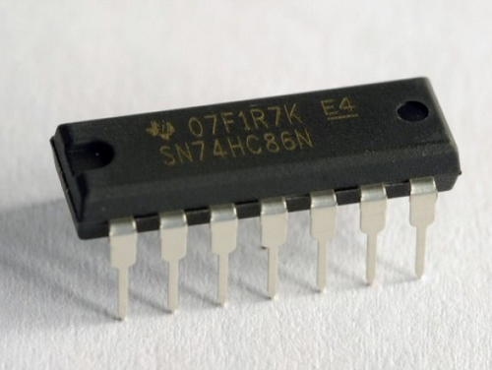

Fig:3.1.5a IC SN-74HC86N

This is used for zero-cross detection of signals coming from op-Amps connected to voltage and current phases .XOR gate output will be 1 when input is of different signals and 0 for input is same signals

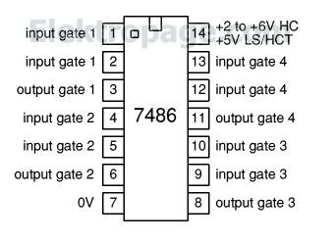

Fig:3.1.5 b Pin diagram of IC -SN 74HC86

The operation of Exclusive OR gate can be explained from Truth table below.

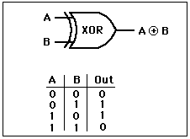

Fig:3.1.5 c Truth table of exclusive or gate

**3.1.6 LCD Display** : A liquid-crystal display (LCD) is a flat panel display, electronic visual display, or video display that uses the light modulating properties of liquid crystals. Liquid crystals do not emit light directly.It is used to show output.It is 20*4 lcd display.

The LCD we are using has 16 pins. Description of each pin is as follows:

Pin No Symbol Level Description:

1. VSS 0V Ground

2 .VDD 5V Supply Voltage for logic

3 .VO (Variable) Operating voltage for LCD

4 .RS High/Low H: DATA, L: Instruction code

5 .R/W -High /Low H: Read L: Write

6 .EH H->L Chip enable signal

7 .DB0 H/L Data bus line

8 .DB1 H/L Data bus line

9 .DB2 H/L Data bus line

10. DB3 H/L Data bus line

11 .DB4 H/L Data bus line

12 .DB5 H/L Data bus line

13 .DB6 H/L Data bus line

14 .DB7 H/L Data bus line

15 .A 5V LED +

16 .K 0V LED-

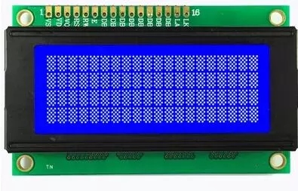

Fig:3.1.6 20*4 LCD display.

**3.2 Software:**

**3.2.1 Arduino IDE:**

**Programming language :** Processing language

* Arduino IDE provides user friendly environment for developing logic for controllers. The IDE environment mainly contains two basic parts: Editor and Compiler where former is used for writing the required code and later is used for compiling and uploading the code into the given Arduino Module.
* This environment supports both C and C++ languages.It works across various type of Arduino boards like  Arduino Uno, Arduino Mega, Arduino Leonardo, [Arduino Micro](https://www.theengineeringprojects.com/2018/09/introduction-to-arduino-micro.html) and many more.

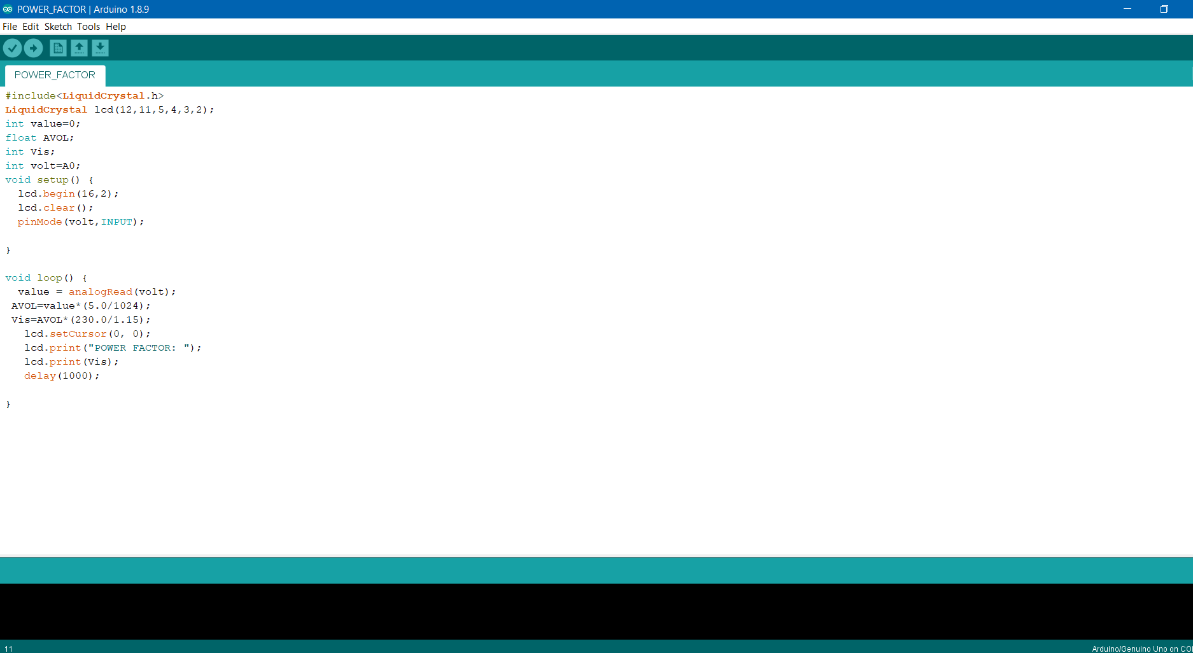

Fig:3.2.1 Arduino IDE view

**CHAPTER 4:**

**ENERGY MEASUREMENT**

**4.1 Measurement of Voltage:** Voltage Measurement is done by using a voltage transformer and stepping down voltage , rectifying and further dividing it to get voltage under 5v which is fed to analog pin of Arduino A0.

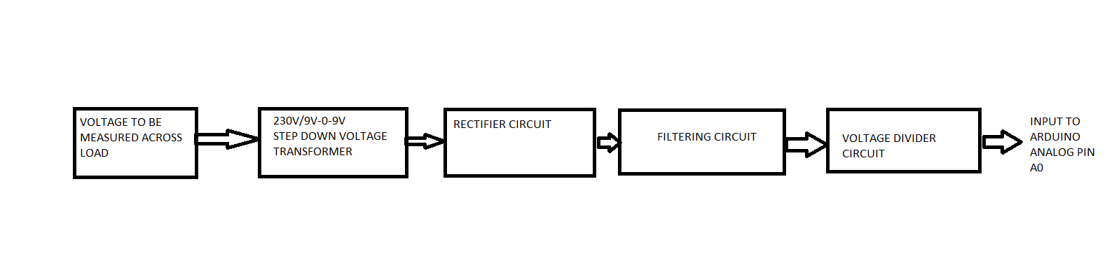

Fig:4.1 a block diagram for voltage measurement

Here stepping down of voltage is done by using a step-down transformer which has primary voltage of 220V and secondary voltage of 9V.This voltage is fed to rectifier circuit containing two diodes IN4007 diodes which rectify the voltage and then its filtered for ripples using 220uF capacitor .It helps in filtering DC voltage output .From here on it is divided using voltage divider circuit containing two resistors of 220 ohm and 1600 ohm resistors. The voltage to Arduino input is taken across 220 ohm resistor to get voltage under 5V to prevent Arduino from high voltages .This voltage across 220 ohm resistor is given to analog pin A0 of Arduino.

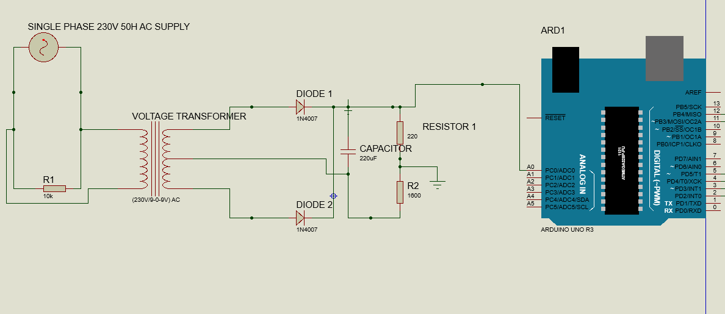

Fig:4.1 b circuit diagram for voltage measurement

**4.2 Measurement of Current:** The current drawn by load is measured in using a current transformer YHDC SCT013.A burden resistor of 33 ohm is connected across it and the output of CT is filtered and fed to analog pin of Arduino A1.

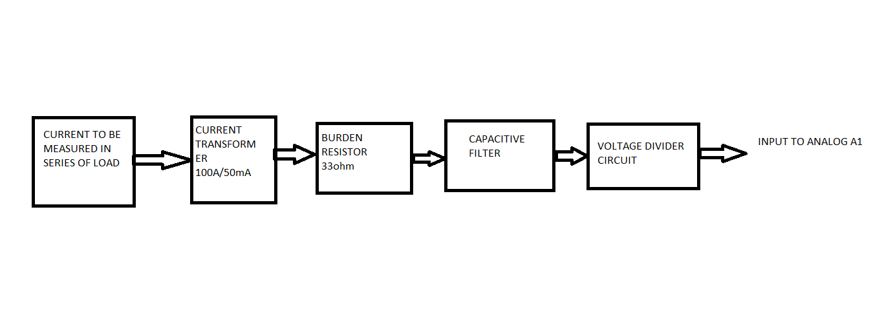

Fig:4.2 a block diagram for voltage measure ment

Current is measured by connecting a current transformer in series with load.This SCT013 is non invasive and can measure upto 100A.A burden resistor of 33ohm is connected across the secondary coil of CT as a precaution to prevent high currents and then a capacitor of 100uF is connected in parallel to it to reduce the ripples and this is fed to voltage divider circuit across it to reduces the voltage and then fed to across analog input of Arduino A1.

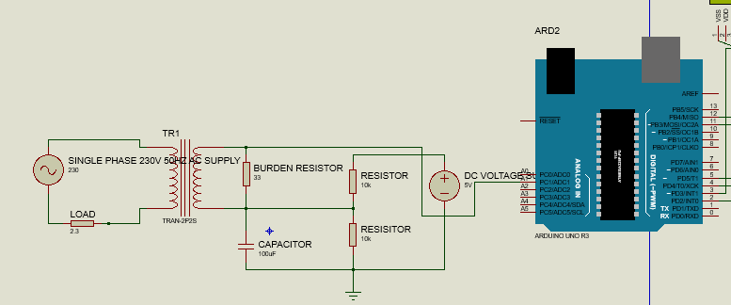

Fig:4.2 b circuit diagram for current measurement

**4.3 Measurement of Power Factor:** The power factor is measured by feeding the voltage and current transformers output to an OP-AMP which converts these output voltage signals the to Square wave forms to around 4V of magnitude.Then these are fed into an XOR gate inputs.XOR gate output will be 1 just when input has different signals so when load is inductive or capacitive XOR gate output will be 1 and XOR gate output will be 0 when load is resistive i.e both current and voltage an current phase starts and ends at same time.This logic is used to get phase shift and power factor.

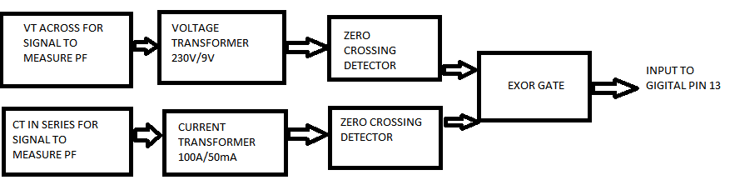

Fig:4.3 a block diagram for power factor measurment

Stepping down of voltage is done by using a step down transformer which has primary voltage of 220V and secondary voltage of 9V.This voltage is fed to two diodes IN4007 diodes which rectify the voltage .The voltage is given to non inverting (pin-3) and inverting (pin-2) terminal of LM-358 operational amplifier.

A current transformer in connected series with load .This CT SCT013 is non invasive and can measure upto 100A.A burden resistor of 220ohm is connected across the secondary coil of CT . This voltage is fed to two diodes IN4007 diodes which rectify the voltage. This voltage is given to to non inverting (pin-5) and inverting (pin-3) terminal of LM-358 operational amplifier.

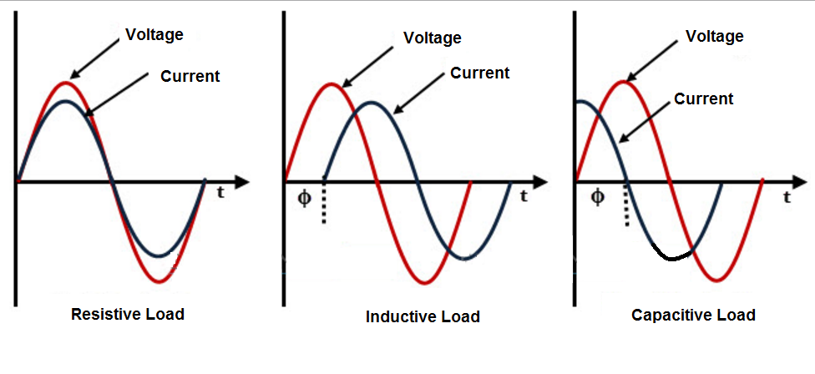

Fig:4.3 b Voltage and Current waveforms during different loads

The output from XOR gate is given Arduino digital pin 13 and a capacitor of 47pf is connected across it before giving to Arduino to reduce ripples.

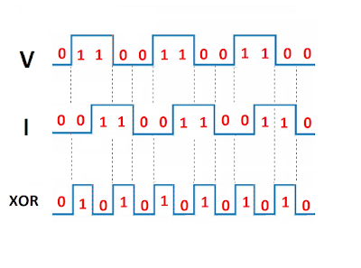

Fig:4.3cXOR gate outputs for different various V&I op-amp outputs

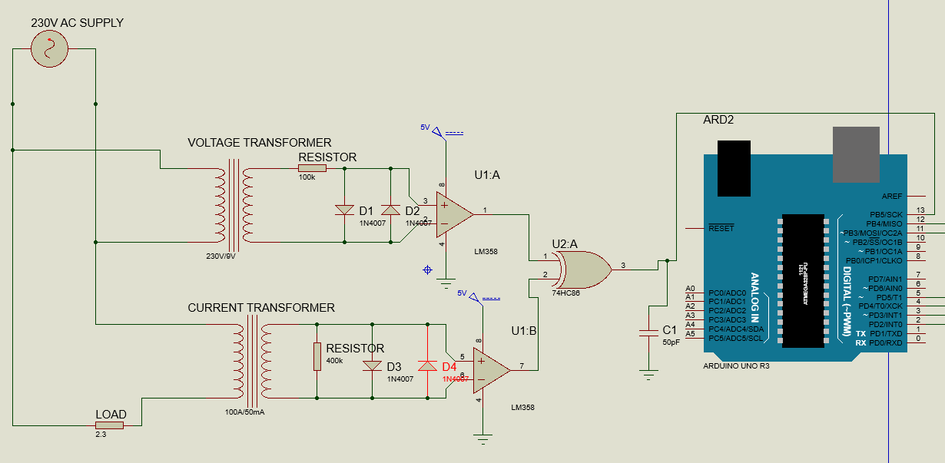

Fig:4.3 b circuit diagram for power factor measurement

20 milli seconds is equal to 180 degrees, So to get phase shift,phase difference between two max value of XOR gate is calculated and it is converted to degrees using Arduino.

**4.3 Measurement of Energy:** Energy is measured by calculating power consumed per unit time.

Expression for power is given by:

**POWER=V*I*cos**() **W**----------------------------------------------4.3 a

Now Energy is calculated by power consumed for each 2seconds since delay of loop in Arduino is set to 2seconds and it is cumulatively added for each iteration. i.e

**Energy = Energy + (POWER * (2.05/60/60/1000)) KW**--4.3 b

**4.4 Measured Energy output on LCD display:** The LCD display terminals are connected in following order for interaction.

RS pin of the LCD module is connected to digital pin 12 of the Arduino. R/W pin of the LCD is grounded. Enable pin of the LCD module is connected to digital pin 11 of the Arduino. In this project, the **LCD module and Arduino are interfaced in the 4-bit mode.** This means only four of the digital input lines( DB4 to DB7)  of the LCD are used. This method is very simple, requires less connections and you can almost utilize the full potential of the LCD module. Digital lines DB4, DB5, DB6 and DB7 are interfaced to digital pins 5, 4, 3 and 2 of the ArduinoThe Arduino can be powered through the external power jack provided on the board. +5V required in some other parts of the circuit can be tapped from the 5V source on the Arduino board. The Arduino can be also powered from the PC through the USB port. The full program for interfacing LCD to Arduino is shown below.

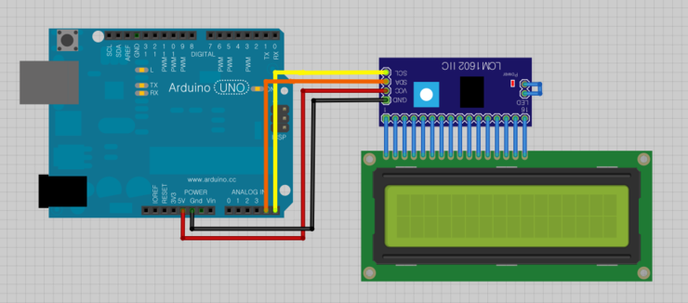

Fig:4.4 Arduino LCD interfacing

**4.5 Arduino Code:** Arduino code for Voltage ,Current, Power factor and Energy calculations is given below:

#include<LiquidCrystal.h>

LiquidCrystal lcd(12,11,5,4,3,2);

int value=0;

float AVOL;

int Vis;

int volt=A0;

#include "EmonLib.h" // Include Emon Library

EnergyMonitor emon1; // Create an instance

int pin = 13;

float rads = 57.29577951; // 1 radian = approx 57 deg.

float degree = 360;

float frequency = 50;

float nano = 1 * pow (10,-6); // Multiplication factor to convert nano seconds into seconds

// Define floats to contain calculations

float rads = 57.29577951; // 1 radian = approx 57 deg.

float degree = 360;

float frequency = 50;

float nano = 1 * pow (10,-6); // Multiplication factor to convert nano seconds into seconds

float pf;

float angle;

float pf_max = 0;

float angle_max = 0;

int ctr;

float AP;

float Energy;

void setup() {

emon1.current(1, 60.5);

lcd.begin(16,2);

lcd.clear();

pinMode(volt,INPUT);

int pin = 13;

}

void loop()

{

//VOLTAGE CODE

value = analogRead(volt);

AVOL=value*(5.0/1024);

Vis=AVOL*(230.0/0.78);

//CURRENT CODE

double Irms = emon1.calcIrms(1480);

// POWER FACTOR CODE

for (ctr = 0; ctr <= 4; ctr++) // Perform 4 measurements then reset

{

// 1st line calculates the phase angle in degrees from differentiated time pulse

// Function COS uses radians not Degree's hence conversion made by dividing angle / 57.2958

angle = ((((pulseIn(pin, HIGH)) * nano)* degree)* frequency);

// pf = cos(angle / rads);

if (angle > angle_max) // Test if the angle is maximum angle

{

angle_max = angle; // If maximum record in variable "angle_max"

pf_max = cos(angle_max / rads); // Calc PF from "angle_max"

}

}

if (angle_max > 360) // If the calculation is higher than 360 do following...

{

angle_max = 0; // assign the 0 to "angle_max"

pf_max = 1; // Assign the Unity PF to "pf_max"

}

if (angle_max == 0) // If the calculation is higher than 360 do following...

{

angle_max = 0; // assign the 0 to "angle_max"

pf_max = 1; // Assign the Unity PF to "pf_max"

}

angle = 0; // Reset variables for next test

angle_max = 0;

lcd.setCursor(0, 0);

lcd.print("Vis:");

lcd.print(Vis);

lcd.setCursor(8, 0);

lcd.print("Irms:");

lcd.print(Irms);

lcd.print("PF=");

lcd.print(pf_max);

lcd.print("EG");

lcd.print(Energy);

AP=Vis*Irms*pf_max;//AP =APPARENT POWER

Energy = Energy + (AP * (2.05/60/60/1000)); //Calculate kilowatt hours used

delay(2000);

}

**CHAPTER 5:**

**WORKING**

When the system is turned ON,it receives voltage,current and power factor inputs across ANALOG A0,A1 and DIGITAL D13 pins respectively.Arduino by following code programmed first calculates voltage from input received across analog input pin A0.

Next it calculates current drawn by load by using input at analog pin A1.

The input across digital pin D13 is received by Arduino and calculate difference between two different high inputs and converted that different into power factor.

Later it calculates Energy used by load from expressions 4.3a ,4.3b and displays output on LCD display.Output values are updated every 2 seconds.

**CHAPTER 6:**

**APPLICATIONS**

* This system shows the energy consumed on daily basis, hence it helps to reduce the consumption by comparing the daily usages.
* The system helps to create awareness to the public regarding their energy consumption and the corresponding charges.
* It can be used for monitoring energy generation in case of solar panels installed at home.
* It can also be used to automatic energy billing system.

**CHAPTER:7**

**CONCLUSION**

Consumers try to reduce their power consumption by replacing their existing appliances to a new set of appliances like LED lights, solar powered equipment, which are not affordable by all types of consumers. Hence it is necessary to use the existing appliances in an optimal manner. This project notifies the consumers regarding their power usage in their day to day life by notifying them about the different combination in which the appliances can be operated effectively within the user’s target limit. Hence a user can effectively manage power by knowing his consumptions.. The proposed system can overcome and improve the challenges of energy efficiency and manageability. The parameters of energy meter can be read correctly and reliably, such as the total energy consumption.

**CHAPTER 8:**

**REFERENCES**

1. Hlaing, W., Thepphaeng, S., Nontaboot, V., Tangsunantham, N., Sangsuwan, T., & Pira, C. (2017). Implementation of WiFi-based single phase smart meter for Internet of Things (IoT). 2017 International Electrical Engineering Congress (iEECON). doi:10.1109/ieecon.2017.8075793   
url:[sci-hub.tw/10.1109/IEECON.2017.8075793](http://sci-hub.tw/10.1109/IEECON.2017.8075793)  
2. Prathik, M., Anitha, K., & Anitha, V. (2018). Smart Energy Meter Surveillance Using IoT. 2018 International Conference on Power, Energy, Control and Transmission Systems (ICPECTS). doi:10.1109/icpects.2018.8521650   
url:[sci-hub.tw/10.1109/ICPECTS.2018.8521650](http://sci-hub.tw/10.1109/ICPECTS.2018.8521650)  
3. Sharmila, P., Sharanya, S., & Soundarya, S. (2018). Effective Power Utilization Based on Electricity Tariff. 2018 Internat2018 International Conference on Computation of Power, Energy, Information and Communication (ICCPEIC)ional Conference on Computation of Power, Energy, Information and Communication (ICCPEIC). doi:10.1109/iccpeic.2018.8525143  
[url:sci-hub.tw/10.1109/ICCPEIC.2018.8525143](http://url:sci-hub.tw/10.1109/ICCPEIC.2018.8525143)  
4.Google reference:

url:https://www.mousa-simple-projects.com/2017/12/power-factor-measurment-using-arduino_18.html